Business Report

Health Care Capstone Project Notes 2
By
Rajesh Mambulli

Table of Contents
Health Care Capstone Project Notes 2 1
1. Recap 4
2. Data Preparation 4
3. Model Building 5
3.1 Parametric Models 5
3.2 Non-Parametric Models 14
3.3 Feature Importance of Tuned Random Forest Model 22
3.4 Feature Importance of Tuned XG Boost Model 23
3.5 Interpretation of the Most Optimum model 23

Table of Figures
Figure 1: Model Summary 5
Figure 2: Model Summary 6
Figure 3: VIF Summary 6
Figure 4: Predicted values 7
Figure 5: Residual Chart 7
Figure 6: Normality of Residuals 8
Figure 7: Q-Q Plot 9
Figure 8: F-Statistic 9
Figure 9: Model Summary 10
Figure 10: Model Coefficients 10
Figure 11: Model Summary 10
Figure 12: Model Summary 10
Figure 13: Model Coefficients 11
Figure 14: Model Summary 11
Figure 15: Model Summary 11
Figure 16: Model Coefficients 12
Figure 17: Model Summary 12
Figure 18: Model Summary 13
Figure 19: Model Summary 13
Figure 20: Model Summary 13
Figure 21: Data Split 14
Figure 22: Model Summary 14
Figure 23:Model Summary 15
Figure 24: Model Summary 16
Figure 25: Model Summary 16
Figure 26: Model Summary 17
Figure 27: Model Summary 17
Figure 28: Model Summary 18
Figure 29: Model Summary 18
Figure 30: Model Summary 19
Figure 31: Model Summary 19
Figure 32: Model Summary 20
Figure 33: Model Summary 20
Figure 34: Model Summary 21

Recap
Earlier in the stage of this project. Exploratory Data Analysis is conducted on the dataset and came to understanding of attributes relations with target variable which is Insurance Cost.
Picked Top 15 Features from the data by some Clustering techniques.

The Top 15 Features which has very strong importance when compared to Target Variable are these:

- years_of_insurance_with_us
- regular_checkup_lasy_year
- visited_doctor_last_1_year
- cholesterol_level
- age
- avg_glucose_level
- bmi
- smoking_status
- weight
- Alcohol
- exercise
- weight_change_in_last_one_year
- fat_percentage
- Gender_Male
- covered_by_any_other_company_Y
These features are considered for the Next phase of the project which is Model Building.

Data Preparation
Splitting the Data into Train and Test which are in 70 and 30 proportions respectively.

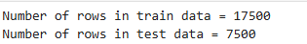

Model Building
Total 8 Models are planned to build on this dataset.
- 4 Parametric Models
  - OLS Model
  - LASSO Regression Model
  - Ridge Regression Model
  - Polynomial Regression Model
- 4 Non-Parametric Models
  - Random Forest Regression Model
  - XG Boost Regression Model
  - AdaBoost Regression Model
  - Support Vector Machine (SVM) Regression Model

Parametric Models

OLS Model
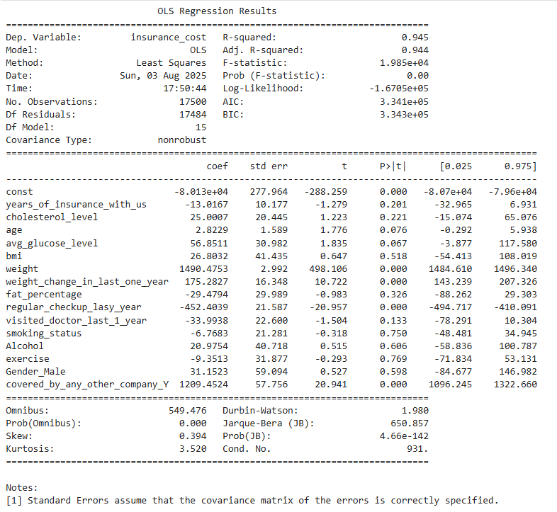
Figure 1: Model Summary

Model Performance on Training data

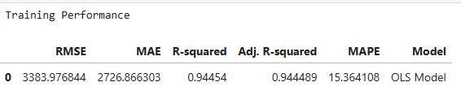
Figure 2: Model Summary

Model Evaluation checks
- TEST FOR MULTICOLLINEARITY
  - If VIF is between 1 and 5, then there is low multicollinearity.
  - If VIF is between 5 and 10, we say there is moderate multicollinearity.
  - If VIF is exceeding 10, it shows signs of high multicollinearity.
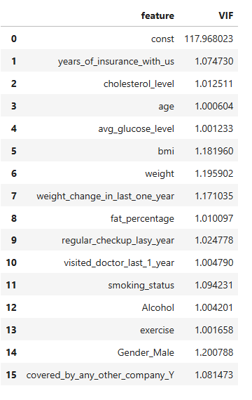
Figure 3: VIF Summary
- There are no multiple columns with very high VIF values, indicating no presence of multicollinearity
- We will systematically drop numerical columns with VIF > 5
- We will ignore the VIF values for dummy variables and the constant (intercept)

- Linearity of variables
- Independence of error terms
- Normality of error terms
- No Heteroscedasticity
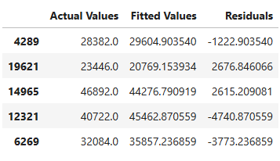
Figure 4: Predicted values
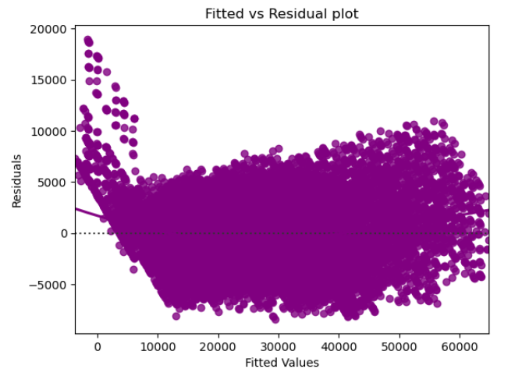
Figure 5: Residual Chart
- The scatter plot shows the distribution of residuals (errors) vs fitted values (predicted values).
- If there exist any pattern in this plot, we consider it as signs of non-linearity in the data and a pattern means that the model doesn't capture non-linear effects.
- We see no pattern in the plot above. Hence, the assumptions of linearity and independence are satisfied.
- TEST FOR NORMALITY
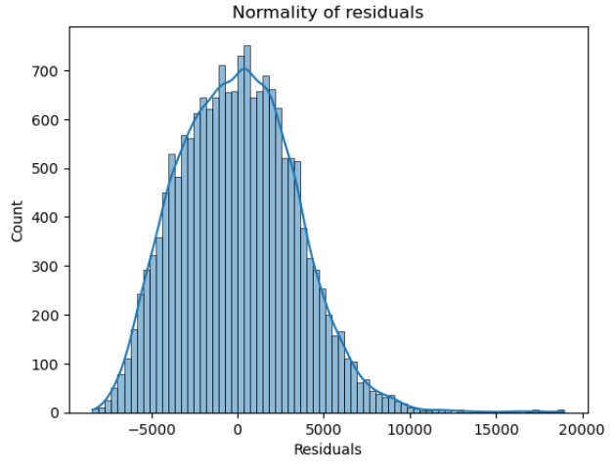
Figure 6: Normality of Residuals
- The histogram of residuals does have a bell shape.
- Let us check the Q-Q plot.
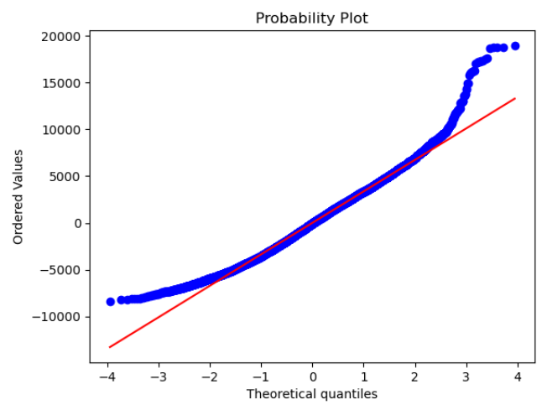
Figure 7: Q-Q Plot
- Shapiro Test
- Since p-value < 0.05, the residuals are not normal as per the Shapiro-Wilk test.
- Strictly speaking, the residuals are not normal.
- However, as an approximation, we can accept this distribution as close to being normal.
- So, the assumption is satisfied.

- F Statistic Test
Figure 8: F-Statistic
Since p-value > 0.05, we can say that the residuals are homoscedastic. So, this assumption is satisfied.

Model Performance on Test data
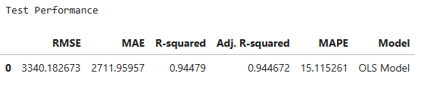
Figure 9: Model Summary
- The model can explain ~94% of the variation in the data

LASSO Regression Model

LASSO Coefficients and Intercepts
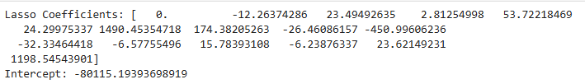
Figure 10: Model Coefficients

Model Performance on Training data
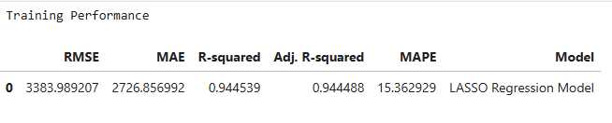
Figure 11: Model Summary

Model Performance on Test data

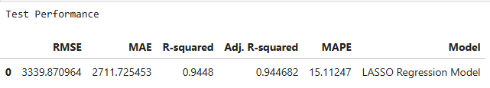
Figure 12: Model Summary

Ridge Regression Model
Ridge Coefficients and Intercepts
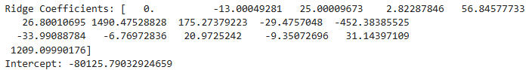
Figure 13: Model Coefficients

Model Performance on Training data
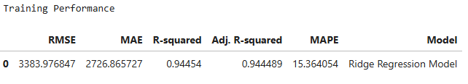
Figure 14: Model Summary

Model Performance on Test data
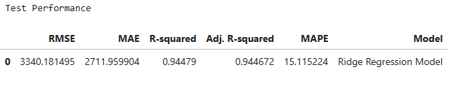
Figure 15: Model Summary

3.1.10 Polynomial Regression Model
Polynomial Coefficients and Intercepts with Degree 2
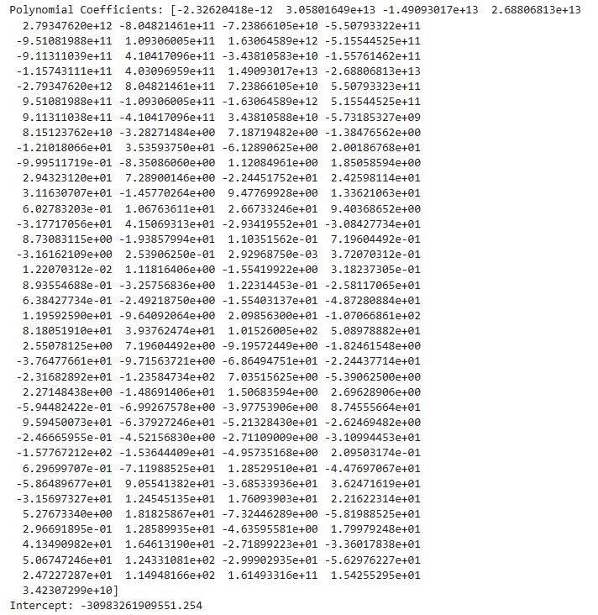
Figure 16: Model Coefficients

3.1.11 Model Performance on Training data
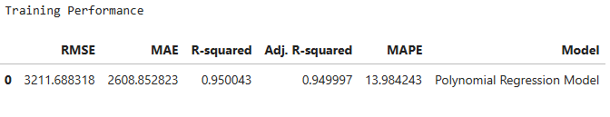
Figure 17: Model Summary

3.1.12 Model Performance on Test data
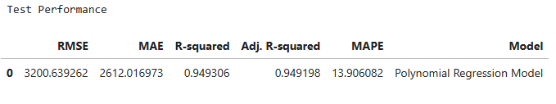
Figure 18: Model Summary

3.1.13 Model Performance Comparison on Training data between Parametric Models

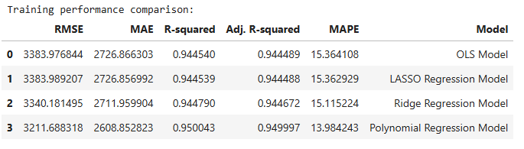
Figure 19: Model Summary

3.1.14 Model Performance Comparison on Test data between Parametric Models

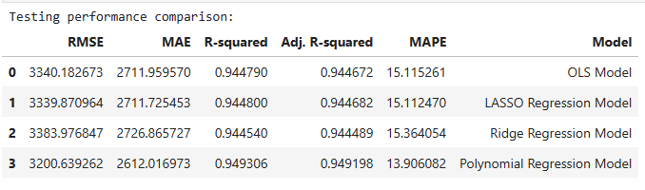
Figure 20: Model Summary
Polynomial Regression Model with Degree 2 has Lesser MAPE and Higher Adjusted R Squared compared to other Parametric Models.

Non-Parametric Models
Data is split into 3 sets, Train, Validation, Test.
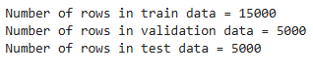
Figure 21: Data Split

Model Performance Comparison on Training and Validation data
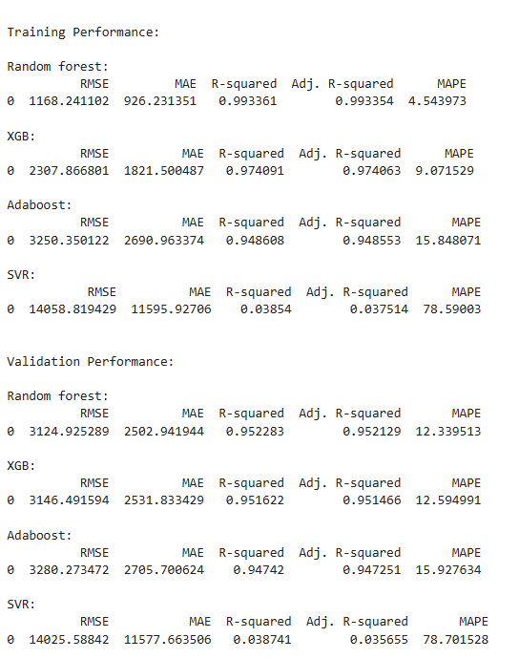
Figure 22: Model Summary

Model Performance Differences on Training and Validation data
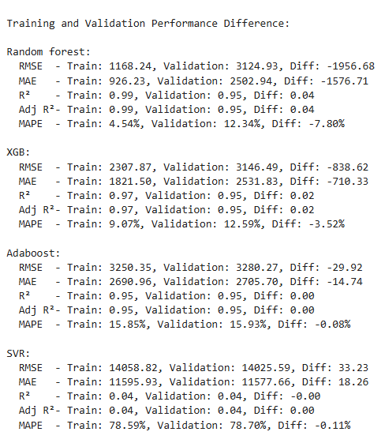
Figure 23:Model Summary

All Model Performance Differences on Training data
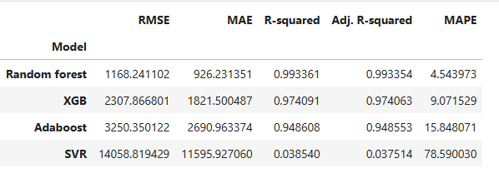
Figure 24: Model Summary
Models like Random Forest, XGB, AdaBoost are good with MAPE but the models might be overfitted. This raises the need for Hyperparameter Tuning all the models.

Tuned Random Forest Regression Model Performance on Train and Validation data
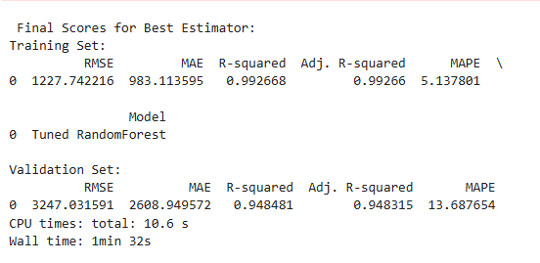
Figure 25: Model Summary

Tuned XG Boost Regression Model Performance on Train and Validation data
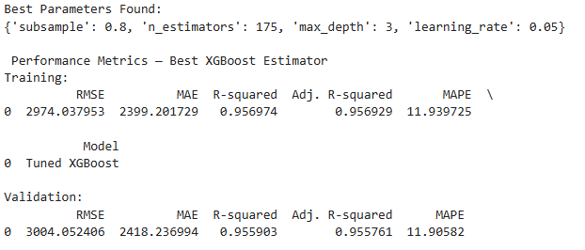
Figure 26: Model Summary

Tuned Adaboost Regressor Model Performance on Train and Validation data
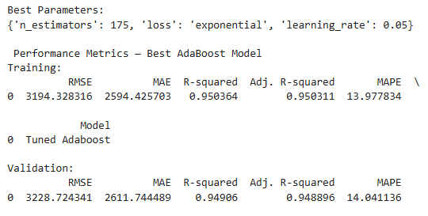
Figure 27: Model Summary

Tuned SVR Regressor Model Performance on Train and Validation data
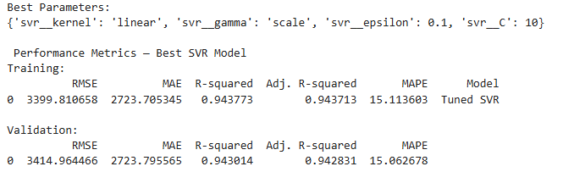
Figure 28: Model Summary
    - Model Performance Comparison on Training data between Non-Parametric Models
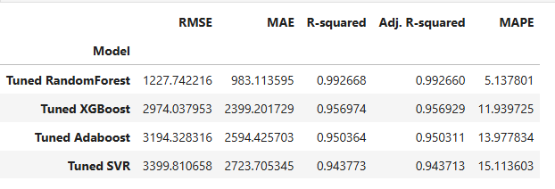
Figure 29: Model Summary

    - All Model Performance Comparison on Training data between Non-Parametric Models
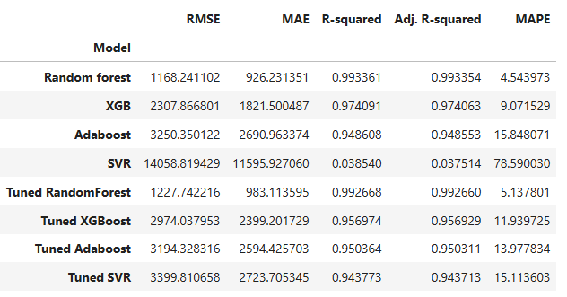
Figure 30: Model Summary

    - Model Performance Comparison on Test data between Non-Parametric Models
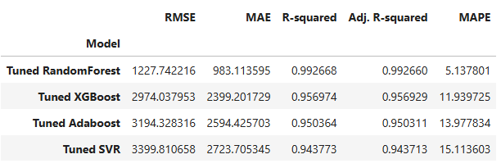
Figure 31: Model Summary

    - All Model Performance Comparison on Test data between All Models
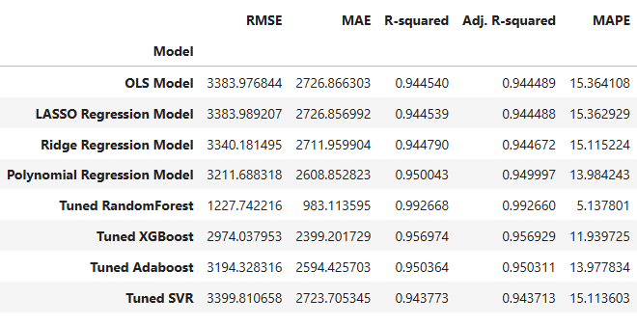
Figure 32: Model Summary

    - All Model Performance Comparison on Train data between All Models Sorted
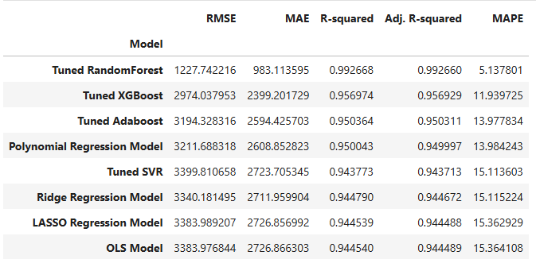
Figure 33: Model Summary

    - All Model Performance Comparison on Test data between All Models Sorted
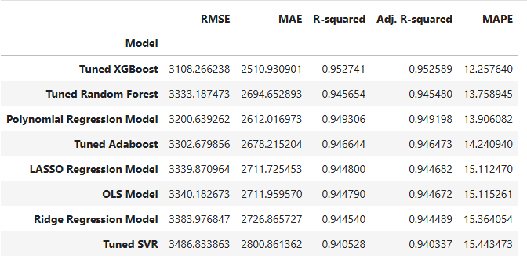
Figure 34: Model Summary
All models have given MAPE less than 15% on test data compared with Train data
This performance is in line with what we achieved with this model on the train and validation sets
So, picking top 2 models to check feature importances

Feature Importance of Tuned Random Forest Model
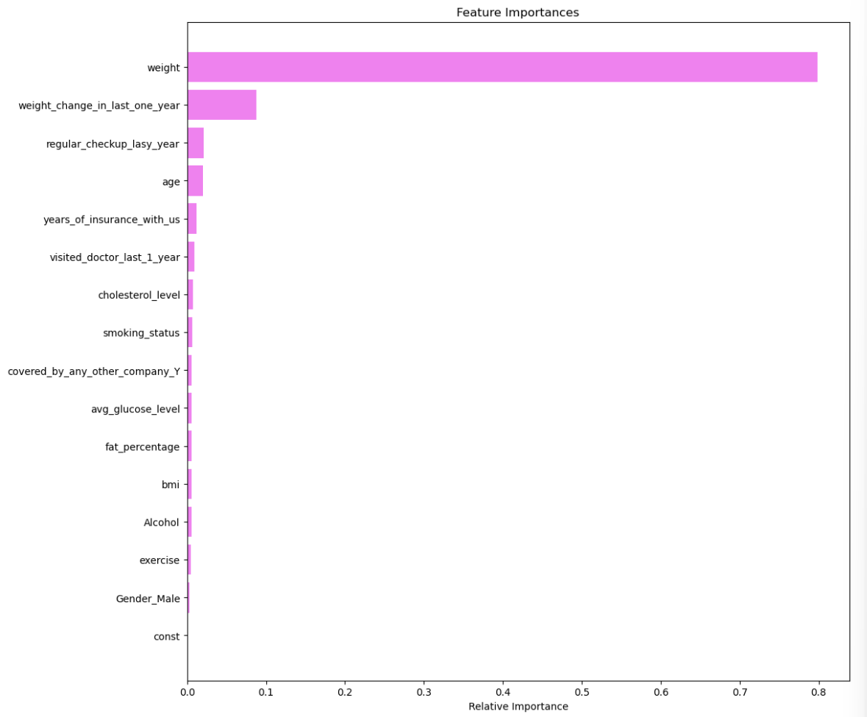

Feature Importance of Tuned XG Boost Model
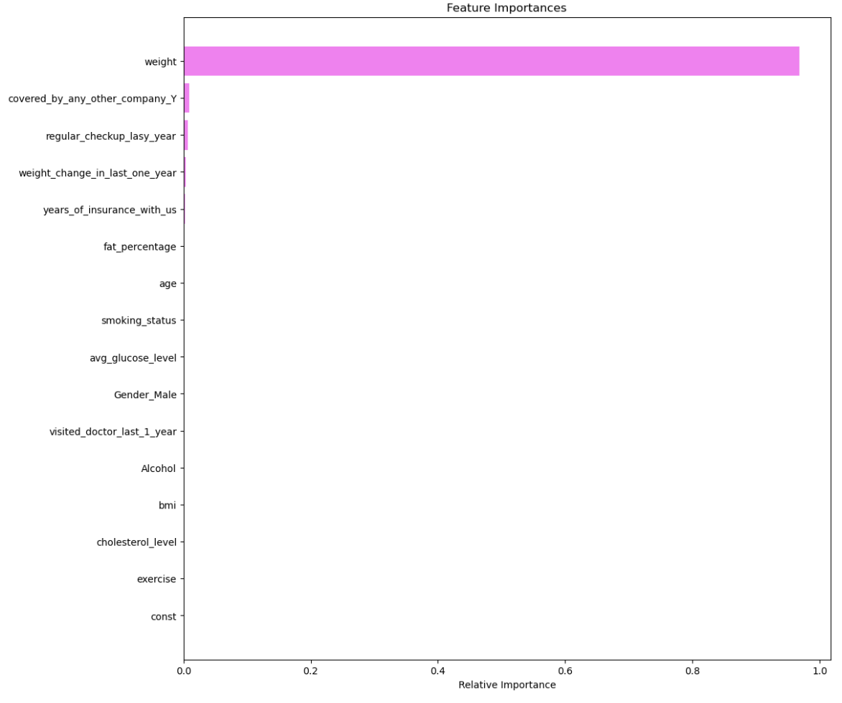

3.5 Interpretation of the Most Optimum model

Tuned XG Boost:
- The Tuned XG Boost model stands out as the most accurate and business-aligned choice in lineup. With a MAPE of just 12.26%, it offers exceptionally tight forecasting performance.
- Its R-squared value of 0.9527 confirms that it captures over 95% of the variance in the target variable, signifying strong feature.
- The model also posted the lowest RMSE and MAE, smoother performance across diverse customer profiles.
- In terms of feature behaviour, XG Boost places overwhelming emphasis on “weight”. Other features like coverage by another insurance company and regular health checkups register minor but intuitive signals, highlighting behavioural and contextual flags.

Tuned Random Forest:
- The Tuned XG Boost model stands out as the slightly lesser accurate than Tuned XG Boost model. With a MAPE of just 13.76%, it offers exceptionally tight forecasting performance.
- Its R-squared value of 0.9457 confirms that it captures over 94% of the variance in the target variable, this model still delivers highly dependable performance — just a notch below XG Boost.
- The slightly higher RMSE and MAE suggest broader prediction intervals but remain well within acceptable thresholds.
- In terms of feature behaviour, Random Forest truly shines in its clarity of feature importances. Not only does it reaffirm weight as the primary driver ~80% importance, but it also surfaces weight change in the last year as a meaningful secondary signal ~10%. Other features like checkups, age, tenure, and lifestyle indicators contribute minimally

